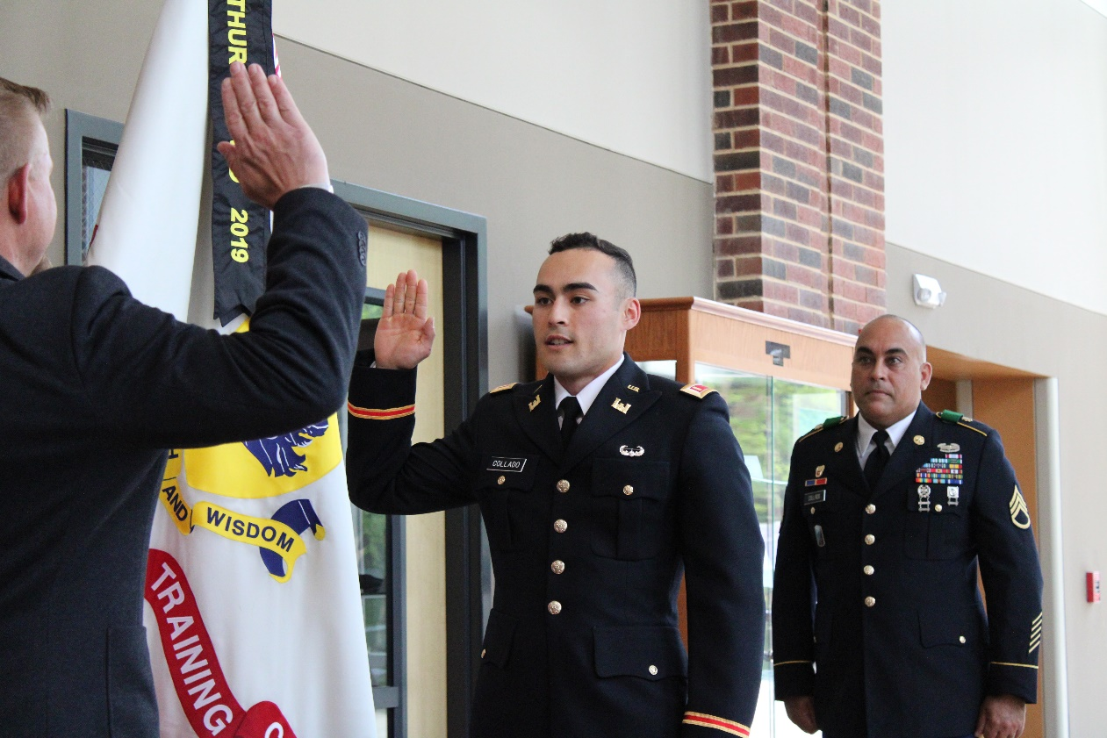

Do you have students interested in a full-ride scholarship or joining the military after high school?
Every year, we award 42 Georgia high school students full scholarships to attend the University of North Georgia (UNG) – The Military College of Georgia and participate in the Corps of Cadets—the Boar’s Head Brigade.
The application process is fairly involved. Detailed information and application instructions are at ung.edu/cadet/scholarships, then select “UNG Military Scholarship.”
The Georgia Military Service Scholarship (GMSS) pays for tuition, fees, room, meals, books, and uniforms for eight semesters; about $80,000 over four years.
In addition to the $80,000 scholarship, most recipients earn pay and benefits as Soldiers in the Guard that total at least $30,000 and up to $55,000 during their time in college, and many are paid even more for occupying leadership roles in the Corps of Cadets.
Applicants who are offered the scholarship enlist in the Georgia Army National Guard, participate in the Corps of Cadets at UNG, earn a bachelor’s degree of their choice, and upon graduating, commission into the Georgia Army National Guard as second lieutenants.
We have a Guard unit on our campus for GMSS recipients and other Guard Soldiers who are cadets: so for the first two years, there is no need to commute to weekend drills. After that, they enter the Simultaneous Membership Program and shadow Guard lieutenants in their Guard units.
GMSS recipients are not deployable while in college.
It is not necessary to enlist in the Guard to apply for the scholarship. However, recipients who accept scholarship offers will enlist before receiving benefits.
Please help us promote this scholarship on your social media sites, your school’s or program’s scholarship web site, and to your high school college/professional counselors.
GMSS Application
UNG Admissions Application
UNG Cadet Scholarships
If you have questions, please contact our office of Cadet Recruiting at cadetrecruiting@ung.edu or call 706-867-2918, or contact our Director of Cadet Recruiting, LTC (Ret) Mike Ivy at mike.ivy@ung.edu or call 706 867-2712. You may also contact your local Army National Guard recruiter.
To ensure that you and your students continue to receive information about UNG, click here to update your organization's point of contact(s) here: https://enroll.ung.edu/register/counselors. For prospective students, please have them complete the following form to receive key information directly: https://enroll.ung.edu/register/cadetinforequest. If you would like to schedule a virtual, in-class, or on-campus briefing by a Cadet Admissions representative, click here to let us know.
Go Nighthawks!
Lieutenant Colonel (Ret) Mike Ivy
Director of Cadet Recruiting and Chair of GMSS Selection Committee

Office of Cadet Recruiting
University of North Georgia
(706) 867-2918

This email was sent to counselor@flintriveracademy.com by University of North Georgia Office of Cadet Recruiting.
Unsubscribe from University of North Georgia (PO Box 1358, Gainesville, GA 30503).

